As a practice we are committed to supporting our patients health holistically and believe health and well-being really is a 360 degree approach, attending to all pillars of wellness and self-care.
Well done on accessing this web page and taking your first step to creating a healthier lifestyle which will hopefully contribute to your contentment in life!
Read the following steps and maybe try out some of the suggestions, monitor how they make you feel and see if you can find a way to keep these positive changes in your daily routine.
BODY NOURISHMENT
MOVEMENT
MIND NOURISHMENT
GOOD HYGIENE
RISK AVOIDANCE
KNOWLEDGE
SOUL NOURISHMENT
WELLBEING

Pillar 1-Body Nourishment
Do you nourish your body with colourful foods filled with much needed vitamins and minerals? Read our body nourishment section and work towards some simple dietary goals that will make a big difference to how you feel! Even get suggestions on where to access healthy recipies and free cooks alongs!
Pillar 2-Movement
Are you managing to reach the recommended150 minutes of moderate intensity activity per week? Do you know about the positive effect exercise has on our mental health? If you’re looking for some ideas of how to move the body at home or on local groups available have a read of our movement section!
Pillar 3-Mental Wellbeing, self awareness, nourishment of the mind
A huge part of our well being is considering how we are emotionally? How do you calm your mind so it can function at its best? For more information on this and links to free breath work, books and podcasts go to our pillar 3 section mind nourishment!
Pillar 3 also contains a directory of Services specific for the Western Trust.
Pillar 4-Soul Nourishment
What nourishes your soul? Does your job or hobbies bring you a sense of purpose and joy? Read pillar 4 for some important questions to ponder!
Pillar 5-Knowledge
Knowledge is power! Are you informed about your health condition? Are you aware of useful and RELIABLE sources of information? Check out pillar 5 for links to excellent websites to help better inform you about your health!
Pillar 6-Risk Avoidance
Do you put yourself at risk with some of your behaviours? Smoking, gambling, eating or drinking too much? It’s very common read pillar 6 for some helpful questions to consider and links to useful resources and contacts.
Pillar 7-Good hygiene
Good hygiene isn’t just about taking a shower or brushing our teeth but also refers to our sleep hygiene are there small changes you could take that would make a big difference to your sleep at night? See pillar 7 for links to helpful resources!

Pillar One;
Body nourishment
We’ve all heard the phrase “you are what you eat” right? Have you thought about that?
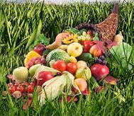
Our bodies are amazing! They are constantly growing, renewing and repairing cells and need the proper fuel to do so. What fuel is going to best help the body to do this? A diet rich in vitamins and minerals, wholegrains, protein and a little healthy fat.
The simplest way to eat well is remember we are all mother earth’s creatures and the food we do best on is food from the earth rather than processed food from factories.
Look at your plate, is 80% of the food coming from the earth in the form of fresh fruits, vegetables and grains? Or is it manufactured in a factory with lots of preservatives, salt and sugar?
The foods from the earth will nourish you and are digested easier by the body therefore promoting gut health. When our gut is feeling out of sorts chances are we are too! We are learning more and more every day about the link of gut health to our mental health so it’s important to prioritise eating healthily for our mental well being as well!
Interested in learning more about the guts link to mental well being? Read more here; https://patient.info/news-and-features/the-link-between-gut-health-and-happiness
This doesn’t mean never indulging in richer foods, this experience is a part of modern life and should be enjoyed from time to time without guilt which we will be able to do more when we know we are nourishing our bodies the other 80% of the time.
So start simple!
- Can you reach a goal of 5 fresh fruits and vegetables per day? Or maybe you make 7 or 10?
- Can you make each meal plate look like the rainbow? Full of much needed vitamins and minerals that will nourish and recharge your cells!
- Can you drink the recommended 2litres of water per day? Did you know being even 1% dehydrated drops cognitive function leading to poorer performance, memory and function?
- Can you cut out that spoon of sugar in your tea?
- Maybe you cut back on that afternoon coffee and reach a healthier caffene intake? (and get a better nights sleep!...did you know that a cup of coffee takes up to 10 hours to leave the blood stream so if your drinking coffee after 2pm no wonder you’re not sleeping well!)
If you want to learn more about healthy eating and what eating habits will best serve you and your body useful information can be found on;
- NHS UK website; https://www.nhs.uk/live-well/
- British Dietetic Association website; Healthy Eating | British Dietetic Association (BDA)
Also check out the Western trust’s page;
Eat Well | Western Health & Social Care Trust (hscni.net)
Here you’ll find lots of helpful links for information on feeding babies, weaning, feeding under 5s, dietary needs through pregnancy, healthy eating for older adults and specific information on vitamin D!
Know what to eat just don’t know how to cook it?
Taking a cooking class can be a lovely method of self care and a chance to meet some new people or try cooking along at home with your favourite celeb chefs on youtube;
- Cooking with friends Jo wicks; https://www.youtube.com/watch?
- Gordon’s Quick & Simple Recipes, Gordon Ramsay; https://www.youtube.com/watch?
- Miguel Barclay & The food medic, Dr Hazel Wallace one pound meals challenge; https://www.youtube.com/watch?
Also check out 100s of healthy delicious recipes from;
- The doctors kitchen website; https://thedoctorskitchen.com/
- Jo wicks recipes on BBC good food; https://www.bbcgoodfood.com/
- The food medic website; https://thefoodmedic.co.uk/
- Delicously Ella website; https://deliciouslyella.com/
How we can support you should you feel you need more help;
- Please speak to one of the doctors about being referred to a dietician if you feel you need dietary support

Pillar Two;
Movement
A huge part of well-being and caring for yourself is also about finding time in your day to move your body and get in some physical activity. This can look different to all of us. For some, this could mean going for a 5km run. For others, this could mean walking the dog, cycling to work or practicing yoga at home for 10 minutes.
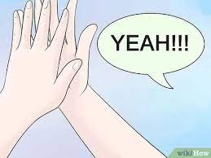
Sometimes, self-care is even getting out of bed on those days where the thought of that seems impossible. What ever you do give yourself a high five! (Sound weird? A high five will help you do the activity you gave yourself a high five for more…how? Positive feedback and neuroplasticity…interested in learning more check out the High Five Habit by Mel Robins)
Now back to exercise...
The point is there are lots of ways to move the body!
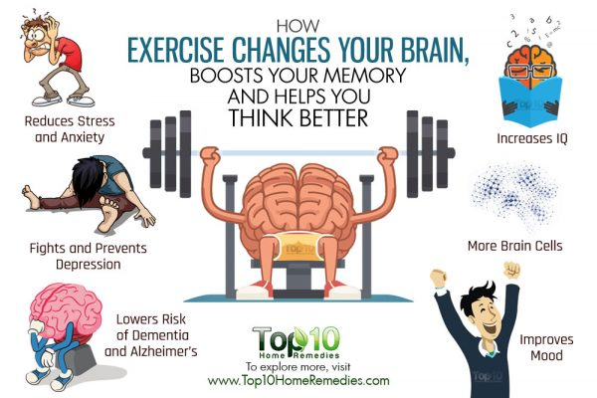
Not only does exercise strengthen our muscles and bones and decrease joint pain but it also helps the mind.
Exercise is energy in motion E-motion! Sometimes the best way to move emotions out the body is to move the body in whatever way feels good for you!
Why not take a walk, jog or run outside?
Even just ten minutes has both physical and mental benefits! Start small and build up to the recommended150 minutes of moderate intensity activity a week.
Some ways to exercise locally…….
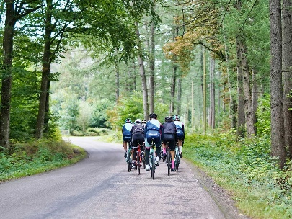
- Do you love to cycle?
Check out the Riverside Walk and Cycle Path in Omagh or find other routes here; https://www.bikemap.net/en/l/
Maybe even join the local cycle club; https://www.facebook.com/groups/omaghwheelers/
- Keen runner or want to start running?
Why not run or jog with others at our local park run every Saturday 9.30 at Omagh Leisure Complex;
https://www.parkrun.org.uk/
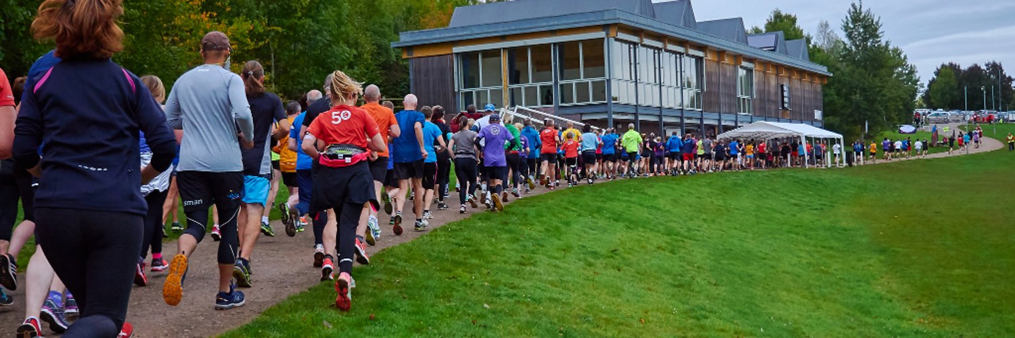
- Omagh leisure centre also now have a range of fitness classes back up and running, check them out here;
Leisure Complexes in the district (legendonlineservices.co.uk)
The leisure centre also has a fantastic gym with a range of cardiovascular and weight training machines available! They also have a 25m swimming pool which is a great way to build up strength and cardiovascular fitness in a non-weight bearing way, making it easy on the joints!
Other local clubs;
Omagh Harriers Athletic club; http://www.omaghharriers.com/
Omagh karate club; https://www.washinkai.co.uk/
Omagh tennis club; http://omaghltc.com/
Set dancing; https://www.dunuladh.ie/
Omagh Spires Special Olympics club; https://m.facebook.com/OmaghSpiresSpecialOlympicsClub/

Omagh golf club; https://www.omaghgolf.co.uk/
If you know of any other clubs or activities you enjoy let us know and we’ll add them so other members of the community can give them a try!

Want to exercise from the comfort of your own home?
The down dog app has a range of different exercise forms including HIT, barre, yoga

YouTube has thousands of free workouts,
Jo wicks HITT workout;https://www.youtube.com/watch?
Love to dance? get the 80s clothes on and have fun dancing along with;
Never stop dancing; https://www.youtube.com/watch?

Yoga is a beautiful practice that exercises both mind and body in union! It is suitable for kids, adults and during pregnancy! There’s restorative yoga, yogic sleep and you can even do yoga on a chair! It really is suitable for everyone!
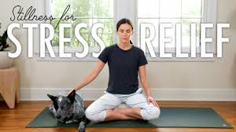
YouTube “yoga with Adrienne” for tonnes of free practices from beginner to intermediate level, here’s a beautiful 15 minute practice to get started with; Stillness For Stress Relief | 15-Minute Meditation | Yoga With Adriene - YouTube
Or just search for eg chair yoga on you tube and hundreds of suitable practices will come up!
Want to get the kids moving more on a rainy day at home;
Jo Wicks Daily PE; Joe Wicks YouTube Daily PE - Bing video
Jo wicks and dugee; you tube joe wicks dugee - Bing video
Cosmic kids yoga;
Sonic The Hedgehog | A Cosmic Kids Yoga Adventure! - Bing video
How we can support you should you feel you need more help;
- Referal to PARS scheme
PARS stands for Physical Activity Referral Scheme, find out more here; https://hscbusiness.hscni.net/pdf/PARS%20Policy%20Doc.pdf
Pillar Three;
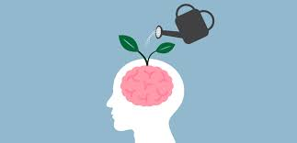
Mental Wellbeing, self awareness, nourishment of the mind
A huge part of our well being is considering how we are emotionally?
Do we gift ourselves space and time each day to allow what we are feeling to come up?
This can look as simple as taking 3-10 minutes each day to breathe, to sit quietly with no distractions, to write down our thoughts, to meditate. Whatever works for you!
We are learning more recently about the power of the breath. The breath is our constant through life, it is always with us do you take time to notice it? Is it shallow is it quick are you holding it? Tuning into your breath and taking slow deep breaths has the ability to switch us from the stressed state operating in our sympathetic nervous system to our parasympathetic nervous system-our rest and digest state.
It is in our rest state rather than our stressed state that we operate best! We have all bought into the idea about “it’s good to be on the go”, “aw he’s doing great sure he’s busy”, we’ve told ourselves “when I get to the end of the to do list I’ll take time for myself”.
The truth is the list will always be there and the more you go go go the less we achieve because as we all know in our stressed states things tend to work against us rather than for us. Gift yourself a few minutes each day to quiet the mind and cultivate inner peace with the breath and the rest of your day will have a sense of ease. When stressful things happen as we know they do being able to come back to your breath will be the greatest gift allowing you to deal with anything in calm collected manner!
Link for breath work;
Deep breathing exercise - Torbay and South Devon NHS Foundation Trust
Breathing exercises for stress - NHS (www.nhs.uk)
Uptatonummolor (guysandstthomas.nhs.uk)
Youtube has lots of useful breathing exercises available;
Box breathing relaxation technique: how to calm feelings of stress or anxiety - YouTube
Breathing Exercises To Stop A Panic Attack Now | TAKE A DEEP BREATH - YouTube
Meditation can be a beautiful way to come back to breath and take time to quieten the mind.
- Guided meditation can take as little as 10mins, try out one of these apps;
calm app
- headspace
Or check out Jay Shetty’s 20 day guided meditation for free on youtube; 20 Days of Live Meditation with Jay Shetty: Day 1 - YouTube
Or Ireland’s wonderful meditation teacher Miriam Hussey; Meditation for Calming the mind, Meeting the Fears & Creating inner Ease - YouTube

Caring for your mental wellbeing is an excellent way to self-care, making sure areas such as life satisfaction, self-esteem and optimism are all in a positive place. If one or more are struggling, self-care is using your knowledge and skills to take action to change! This could mean seeking help from a professional, conducting your own research, or using tools you already know to improve your overall well-being.
Reading self help books can be an incredible way to improve your mental wellbeing.
Have you heard of the Reading Well scheme available at local Libraries? Reading Well supports you to understand and manage your health and wellbeing using helpful books which are all recommended by health experts, as well as people with lived experience of the conditions and topics covered and their relatives and carers. They have specific booklists for children, long-term conditions, dementia and carers.
Find out more here; https://reading-well.org.uk/books/books-on-prescription
Podcasts are another incredible and free resource to learn more about health and improving mental wellbeing.
Check out Just One Thing Michael Mosley, Feel Better Live More Dr Chattergee, Delicous Ways to Feel Better Ella Mills, On Purpose Jay Shetty, Healing Soundboard The holistic Psychologist, SuperSoul Oprah, The Good Glow Georgie Crawford,
As a practice we are committed to helping you improve your mental well-being if you feel you would like to discuss this with a doctor please get in touch.
There is a counselling service we can refer you to or if required to the mental health team.
Please also access the link below which provides a directory of Services to help improve emotional health and wellbeing for the Western Trust. There are contact numbers for services that deal with mental health, eating disorders, addictions, domestic violence, family support, student support, sexual health, bereavement, children & young people, carers support, employment and training, housing and benefits and many more!
Western_area_card_2020.pdf (hscni.net)

Pillar Four;
Soul nourishment
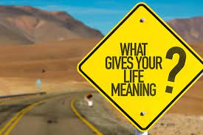
What nourishes your soul? Does your job or hobbies bring you a sense of purpose and joy?
To live with purpose is life’s greatest gift. Take time to evaluate have you enough in your life which nourishes your soul. If not maybe some of the suggestions in this page will help nourish you in this way.
Perhaps joining a club or sport, reading more, taking up a course at our local college find what sparks your interest and go for it! Life isn’t about our achievements it is about learning and enjoying the journey!

Pillar Five;
Knowledge and Health Literacy
Knowledge is power! The more we know about our health and the conditions we have and how to manage or improve them the better! We are always here to support you in the management of your health condition but if you’re interested in learning more here are websites with reliable patient information;
Nhs website; https://www.nhs.uk/
Patient info website; https://patient.co.uk/
Mind mental health website; https://www.mind.org.uk/
You can search for any health condition in these websites and will have useful, factual information.
They often provide links to other websites which may also be of use.

Pillar Six;
Risk Avoidance
By avoiding or limiting your use of toxic substances and risky behaviour, you are automatically showing yourself self-care. This can include things like avoiding tobacco and alcohol use, avoiding dangerous situations. Self-care can also be choosing to use sunscreen and limiting screen time.
Very often a good question to ask when tackling a risky behaviour can be why do I want to stop?
Do you want to feel healthier?
Do you want to be at a loved ones wedding in the future?
Think about it, when you find your why and you feel strongly enough about it having the will to make the change will be easier!
Please also be gentle with yourself very often an addiction pattern has developed as a way to cope with troubles in our lives and so counselling may also be beneficial to work through this. There are a number of counsellors who work privately in the Omagh area or we can refer you to the practice counsellor.

Other helpful resources;
Smoking cessation help;
The western trust has a pack, helpline, clinic what ever you feel will work best for you!
https://westerntrust.hscni.net/healthy-living/stop-smoking/

Drug & Alcohol support;
https://www.drinkwiseagewell.org.uk/
Daisy West | Start360 Northern Ireland
https://www.familysupportni.gov.uk/Service/4278/drugalcohol-misuse/alcoholics-anonymous--northern-ireland
https://www.familysupportni.gov.uk/Service/2341/drugalcohol-misuse/alanon-family-group-meetings-omagh

Gambling support;
Gamblers Anonymous

As always please let us know should you require support in this regard.

Pillar Seven;
Good Hygiene
Of course, self-care is about taking those long epsom salt bubble baths, or going to the spa. But self-care does not have to be as elaborate as this.
For some of us, having a shower or brushing our teeth is a huge accomplishment in our day. This is still self-care and looking after your holistic health so high five yourself when you do these!
Sleep hygiene is important, the fast pace of modern society with an ever growing number of screens available can make sleep difficult to achieve however if you stick to good sleep hygiene it shouldn’t be a problem, read more about how to achieve health sleep hygiene here;
https://www.sleepfoundation.

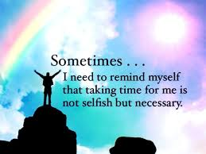
Remember...self-care isn’t selfish, it’s necessary!

